JD Last Review Date | July 2026

Executive Assistant

Team - CEO Office (under review) | Team responsibility - 0 FTE
Manager – Chief Executive (under review) | Budget responsibility - £0
Directorate – CEO Office (under review) | Job grade - 4
Location – Northallerton/hybrid

Role Purpose

The Executive Assistant provides high-quality executive support services to the Chief Executive, Executive Team, Chair of the Board, Committees and Board Members.

The role holder will ensure the efficient management of executive team business, Board and Committee administration, governance compliance and corporate decision-making processes, enabling the organisation to operate effectively and in accordance with regulatory and legal requirements.

Responsible for the co-ordination of all external stakeholder events for the Chief Executive and Executive Team including arrangements, diary, communications and media as required.

They also provide project support to the executive team, including leading on delivery of small projects as required.

The role holder will act as a trusted professional, maintaining the highest levels of confidentiality, integrity and professionalism.

Organisational Structure
Under review as of July 2026
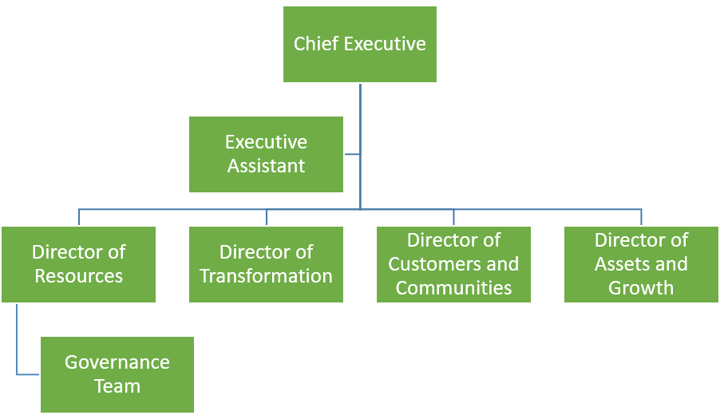

Main responsibilities
Chief Executive Support
- Provide comprehensive executive support to the Chief Executive, managing a complex diary, meetings, priorities and correspondence.
- Act as the first point of contact for internal and external stakeholders on behalf of the Chief Executive.
- Provision of assistance and information to managers, colleagues and outside organisations on the Chief Executives behalf.
- Provide a responsive and professional point of contact for customers contacting the Chief Executive directly, coordinating follow-up actions and signposting enquiries to the appropriate teams while ensuring timely responses.
- Manage and develop the organisation's stakeholder relationship management processes and systems to support effective engagement, collaboration and communication with key external partners, customers and stakeholders.
- Coordinate all stakeholder events on behalf of Chief Executive working with internal and external stakeholders to ensure they run smoothly and receive appropriate media coverage.
- Complete ad hoc projects on behalf of Chief Executive reporting back as appropriate.
- Support strong relationships with external partners, including relationship building and the sharing of appropriate information.
- Support meetings through agenda management, capturing minutes, and working with colleagues to ensure agreed actions are undertaken.
- Represent the Chief Executive in project progress and follow up action logs.
- Act as the eyes and ears of the organisation, providing insight to support good decision making and communications.
- Support and maintain confidentiality in conversations with partners and colleagues, some of which will be of a sensitive nature.
- Maintain sensitive and confidential information with discretion.
- Arrange travel, events and external meetings where required.

What does success look like?
The Chief Executive is receiving high-quality support, with schedules, projects and diary’s all being managed effectively. Communication between the Chief Executive, external stakeholders, and the Executive Team is positive, leading to increased productivity and an improved organisational reputation. The role holder is focussed on detail and accuracy and ensures that all work meets a high standard.

Executive Team Support
- Administrative work for the Executive Team, including assisting in the production of presentational material and reports.
- Project support for the executive, taking on projects as required with direction from executive director to deliver specific outcomes and results.
- Co-ordinate the management of colleague activities and meetings with Executive Team such as townhall meetings, team meeting attendance.
- Produce accurate minutes and action logs.
- Monitor progress against agreed actions.
- Coordinate Executive meetings, workshops and planning sessions.
- Arrangements for the travel and attendance of the Chief Executive, Chair and Board Members, as necessary, at meetings, courses, seminars and other functions.
- Welcoming visitors of Board Members and, where appropriate, Executive Team to Broadacres House.
- Preparation of agendas, reports, action logs and publication of board packs in online apps in connection with meetings of the Board and its Committees.

What does success look like?
Projects are completed efficiently, and deadlines are consistently met. A proactive approach to problem-solving and careful attention to detail ensure that reports, presentations, and administrative tasks related to the board are of high quality. Visits and event planning are well-organised, and complex travel and diary arrangements are managed effectively.

Governance
- Support the Governance Manager in the maintenance of the Governance folder on SharePoint for matters relating to Boards, Committees and Chief Executive correspondence.
- Support for the Broadacres Chair, Board and Committees.
- Produce accurate minutes and action logs.
- Preparation of agendas, reports, action logs and publication of board packs in online apps in connection with meetings of the Board and its Committees.
- To organise and attend events such as the Group’s Annual General Meeting.
- Support the annual Board Effectiveness process including Board and Committee member performance appraisals
- Support Board recruitment, induction and development.
- Coordinate Board development sessions.

What does success look like?
The SharePoint folder is well managed and up to date at all times and all are able to easily access the information they require when they require it.

General
- To comply with Broadacres policies, procedures and code of conduct.
- To ensure all work undertaken and services provided are in compliance with the data protection legislation.
- Comply at all times with all organisational policies and relevant legislation including Data Protection, Equality & Diversity, Health & Safety and Financial regulations.
- To carry out any other duties consistent with the level of responsibilities of the post as may from time to time be required.
- Promote and demonstrate commitment to equality, inclusion and diversity ensuring BHA develops and promotes positive practices in all its customer activities.
- Embrace and promote the corporate plan, mission, vision, values and conduct of the association.
- Such other duties as may from time to time be allocated to the postholder, which are consistent with the nature of the post.

What does success look like?
An effective colleague delivering high quality support to the Chief Executive, Executive Team, Board and Committees. The role holder fully embraces the corporate strategy and values, regularly communicates Broadacres’ performance and progress with teams, ensures that operational processes and practices are complied with and inspires colleagues to deliver great customer experience.

Executive Assistant
Person Specification
Job Requirements | Essential | Desirable | Method of Identifying Criteria
Experience | Significant experience as an Executive PA or EA  Managing complex diaries and competing priorities  Minute taking in formal meetings  Managing confidential information  Working with senior stakeholders | Supporting Boards within regulated organisations | Application form  Interview  (may include presentation or occupational test where appropriate)
Skills | Exceptional organisational skills – able to successfully manage competing priorities/projects and work to tight deadlines in a rapidly changing environment, planning, generating and adapting solutions accordingly.  Attention to detail with a meticulous approach to tasks, ensuring there is accuracy in work, and nothing is overlooked.  High levels of IT literacy and able to promote digital ways of working.  Highly developed written and verbal communication skills inc. tailoring communications to different audiences.  Good project management skills - able to manage projects to time and achieve deliverables  Ability to manage competing priorities.  Excellent minute-taking skills.  Ability to work independently.  Ability to exercise sound judgement. |  | Application form  Interview  (may include presentation or occupational test where appropriate)
Knowledge | Familiarity with office software (e.g., Microsoft Office Suite) and tools for project management, communication, and scheduling.  A strong understanding of office management, scheduling, correspondence, and record-keeping.  Knowledge of Board and Committee administration.  Understanding of confidentiality and information governance. | Understanding of corporate governance | Application form  Interview  (may include presentation or occupational test where appropriate)
Special Requirements | Willing and able to work outside normal office hours.  Commitment to and understanding of Equal Opportunities/Diversity.  Discretion and confidentiality. |  | Application form  Interview  (may include presentation or occupational test where appropriate)
Qualifications | 5 GCSEs |  | Application form

