Job Code: TBC

Role Purpose
The role holder will support the management of a portfolio of debt investment transactions and partner relationships for successful outcomes i.e. delivery, value, return/recovery and growth. Investments include a variety of funding structures and solutions across a range of asset class sub sectors.
The role holder will work collaboratively supporting the lead Portfolio Manager in ensuring strong stewardship through effective client management, which includes managing and mitigating risks, regular monitoring, reporting and assurance.
The role consistently demonstrates and embeds the values and behaviours in daily work, contributing to a positive and inclusive culture.

Responsibilities
- Support delivery of housing starts, completions, unlocking of land, and budgeted spend aligned with the National Housing Bank Business Plan and annual targets.
- Prepare credit submissions, payment requests, and instruct legal documentation to maintain compliance and quality standards.
- Maintain oversight of portfolio performance and provide assurance through accurate data reporting and stewardship activities.
- Monitor and manage risk profiles across transactions, identifying early signs of deterioration and work collaboratively with the lead Portfolio Manager implementing corrective actions in collaboration with Risk and Distressed Investments.
- Analyse portfolio metrics and performance data to draft and produce high-quality reports and recommendations.
- Contribute to policy and process reviews, recommending and implementing improvements to enhance efficiency and compliance.
- Build strong relationships with clients and professional advisers to achieve collaborative and commercially sound outcomes.
- Ensure Agency compliance with terms of transaction agreements and monitor client obligations, including drawdowns, payments, and reporting requirements.
- Communicate effectively with internal and external stakeholders, delivering clear, timely, and accurate reports and presentations.
- Work collaboratively across teams to share best practice and support organisational objectives.

Additional information

Qualifications, knowledge and experience
- Degree-level qualification or equivalent experience in Banking, Finance or a related field.
- Proficient understanding of cashflow analysis and financial modelling.
- Understanding of deal execution documents (e.g. Shareholder Agreements, Loan Agreements).
- Experience in risk and client management across real estate lending portfolios, with development finance experience preferable.
- Strong organisational skills with the ability to manage multiple priorities and meet deadlines.
- Effective communication skills, both written and verbal, with confidence in engaging internal and external stakeholders.
- Ability to analyse information, identify issues and contribute to practical solutions.

Job Function / Family
Real Estate Loans Portfolio Mgmt : We manage loan investment delivery after contracting. There are 25+ portfolio holding roles, currently responsible for managing £3bn of funding over 175+ building sites across our funding programmes. We monitor performance, identifying and managing emerging risks, funding levels and ongoing support and growth opportunities (partner / portfolio). We undertake risk assessments covering delivery, credit, and reputational risk across our portfolio of loans. We complete transaction variations and restructures and are responsible for creating and maintaining positive client relationships. We deal with the day-to-day monitoring of portfolio schemes, including site visits, review of Independent Monitoring Surveyor reports, monthly loan drawdowns or recycling requests, and ensuring the maintenance of internal records.

Role Classification
Job Level
Level 15
Values and behaviour framework
All colleagues
Core behaviours that everyone within the organisation should aspire to achieve.
Legend
 | Low priority |  | Normal priority |  | High priority |  | Not assessable
  c
  c
  c
  g

Technical Skills
Technical skills for specific professional areas in the agency.
Banking Regulatory and Compliance | 0 | 1 | 2 | 3 | 4
Risk Monitoring and Identification | c | c | c | c | c | Working: Hands-on experience and application.
Corporate Finance | 0 | 1 | 2 | 3 | 4
Financial Analysis | c | c | c | c | c | Working: Hands-on experience and application.
Project and Program Management | 0 | 1 | 2 | 3 | 4
Project Management | c | c | c |  | c | Working: Hands-on experience and application.
Safety, Quality and Risk Management | 0 | 1 | 2 | 3 | 4
Analysis of Real Estate Due Diligence | c | c | c | c | c | Working: Hands-on experience and application.

Skill Descriptors

Banking Regulatory and Compliance
Risk Monitoring and Identification: Monitors, identifies and assesses sources of financial systems risk.
★ Required level: Working: Hands-on experience and application. (2)
- Follows established processes for monitoring and identifying potential sources of financial risk (e.g. identification, analysis, assessment and management).
- Examines the output of automated monitoring tools and performs regular checks in line with risk mitigation controls.
- Applies appropriate methods for interpreting financial risk data (e.g. statistics, trends and themes from data).
- Provides input into the development of guidelines, principles and approaches to assist decision-making where financial risk is a factor.
- Proactively reviews current processes and methods with a view for improving financial risk monitoring and identification.

Corporate Finance
Financial Analysis: Analyses financial data to provide insights and recommendations for decision-making.
★ Required level: Working: Hands-on experience and application. (2)
- Analyses financial data to identify trends and patterns.
- Assists in preparing financial reports and forecasts.
- Documents financial analysis processes and findings accurately.
- Follows established financial analysis methodologies and guidelines.
- Utilises financial analysis tools and software effectively.

Project and Program Management
Project Management: Plans, controls, monitors and completes projects, ensuring efficient utilisation of resources, to achieve successful project outcomes.
★ Required level: Practitioner: Working: Hands-on experience and application. (2)
- Need to add formal description:
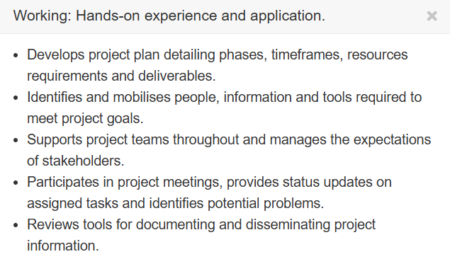

Safety, Quality and Risk Management
Analysis of Real Estate Due Diligence: Analyses real estate due diligence to assess risks and opportunities.
★ Required level: Working: Hands-on experience and application. (2)
- Assists in reviewing real estate due diligence documents for accuracy and completeness.
- Conducts site visits to gather relevant information for real estate due diligence.
- Documents findings from real estate due diligence activities in a clear and organised manner.
- Follows established procedures for conducting real estate due diligence processes.
- Participates in discussions to analyse real estate due diligence results and implications.

Generic Skills
Business, Leadership and Management, and Personal business skills that span the agency.
Business | 0 | 1 | 2 | 3 | 4
Customer Focus | c | c | c | c | c | Working: Hands-on experience and application.
Risk Management | c | c |  | c | c | 1 to be added
Leadership and Management | 0 | 1 | 2 | 3 | 4
Results Orientation | c | c | c | c | c | Working: Hands-on experience and application.
Personal | 0 | 1 | 2 | 3 | 4
Communication | c | c | c | c | c | Working: Hands-on experience and application.
Problem Solving | c | c | c | c | c | Working: Hands-on experience and application.
Relationship Building | c | c | c | c | c | Working: Hands-on experience and application.

Skill Descriptors

Business
Customer Focus: Responds to customer's needs in a manner that provides added value and generates customer satisfaction.
★ Required level: Working: Hands-on experience and application. (2)
- Helps customers determine how to access and interpret meaningful information for decision-making.
- Responds to internal and external customer needs in a manner that consistently adds value.
- Escalates systemic problems that could affect customer satisfaction.
- Recommends new products and services based on changing customer needs and success criteria.
- Focuses on customer satisfaction and responds to customer needs.
- Identifies and provides suggestions for resolving escalated customer problems or issues.

Stakeholder Management: (Need to add formal description)
Required Level 2
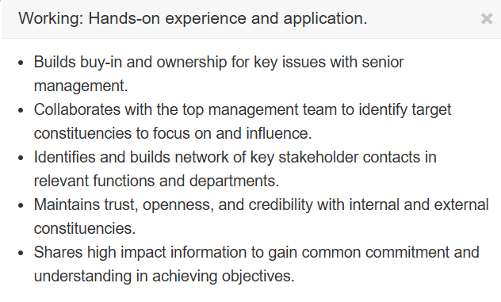
Risk Management: Planning and implementing organisation-wide processes and procedures to manage, assess and minimise exposure to risks of various kinds.
★ Required level: (1)
- Need to add formal description:
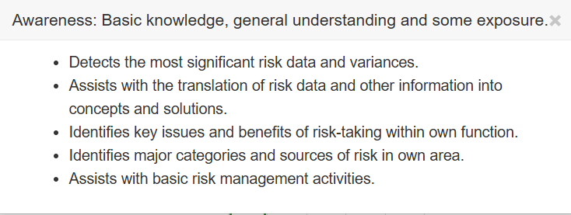

Leadership and Management
Need to add formal description:
Accountability (2)
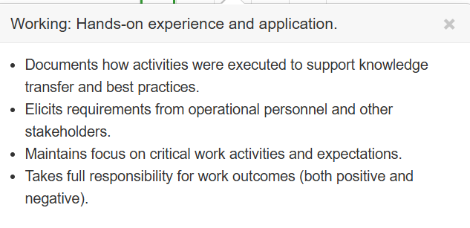
Results Orientation: Drives critical activities to completion.
★ Required level: Working: Hands-on experience and application. (2)
- Focuses team members on key quality and performance drivers for work assignments.
- Maintains own morale and helps others drive tasks to completion as appropriate.
- Organises work such that important items get done first.
- Provides assistance to team members about methods for analysing and addressing the root causes of problems.
- Identifies opportunities for process improvement/re-engineering in own work area (e.g. improves, eliminates or outsources any non-value added activities).
- Holds self and others accountable for delivering on all commitments.
- Documents how results were obtained to support knowledge transfer and best practices.

Personal
Communication: Provides information and messages in a way that produces clarity and impact.
★ Required level: Working: Hands-on experience and application. (2)
- Demonstrates active listening skills by acknowledging audience’s comments and questions.
- Reinforces important messages by responding, clarifying, reinforcing and summarising conversations.
- Consistently encourages others to ask critical questions and share their ideas and concerns.
- Conducts discussions that are sincere and fully expressed.
- Adapts communication messages, methods and influence strategies to the person or audience.
- Supports written ideas with graphics, tables, models and matrices, where appropriate to improve impact.
- Reviews others' communications for substance, editorial quality and visual quality.
Problem Solving: Applies problem-solving techniques and tools to resolve problems effectively.
★ Required level: Working: Hands-on experience and application. (2)
- Applies the concept of task analysis to break down a problem into its constituent parts.
- Selects standard procedures and best practice for problem analysis and resolution.
- Engages the team’s collective expertise to develop scenarios for resolving problems.
- Escalates systemic problems that affect multiple organisational units.
- Adapts solutions to the nature and urgency of the problem and to the resources at hand.
Relationship Building: Develops trusting relationships by valuing others' contributions and works with others in a constructive and collaborative manner.
★ Required level: Working: Hands-on experience and application. (2)
- Networks to develop mutually beneficial relationships over time.
- Perceives and acknowledges the different concerns and goals driving other groups and functions.
- Develops meaningful relationships that can be leveraged to produce benefits for the organisation.
- Initiates and encourages team meetings that produce results.
- Selects the best relating style for various situations and personalities.
- Responds sensitively to other’s concerns.

